**WEEK – 1 ASSIGNMENT: Importing, Pre-Processing and Data Modelling**

* **AIM:**
* The primary objective of this project is to analyse energy consumption trends across various buildings and regions in cities of USA, leveraging Power BI tool to gain actionable insights.
* The analysis will majorly focus on understanding power usage patterns, identifying cost-saving opportunities, and predicting future consumption trends.
* **REQUIREMENTS:**
* **Functional Requirements:**

1. Analyse daily energy consumption data for water, electricity, and gas across multiple buildings in different cities.
2. Identify high and low energy consuming buildings and regions.
3. Calculate total energy costs based on annual rates for each energy type.
4. Provide visualizations to highlight trends, seasonal variations, and anomalies in energy consumption.
5. Predict future energy consumption trends using historical data.

* **Non-Functional Requirements:**

1. Ensure data integrity and accuracy throughout the analysis.
2. Optimize Power BI reports for better performance and interactivity.
3. Deliver insights in an easy-to-understand manner for wider audience.

* **TOOLS USAGE:**
* **Power BI**: To create interactive dashboards and visualizations for energy consumption and cost analysis.
* **Microsoft Excel**: For preliminary data cleaning, transformation, and exploration.
* **SYSTEM REQUIREMENTS:**
* **Operating System:** Windows 10 or later / macOS 10.15 or later.
* Power BI Desktop (latest version).
* Microsoft Office Suite (Excel 2016 or later).
* **DATA IMPORTING & WRANGLING – Steps Done:**

**Dataset Used:** Energy Consumptions Dataset.xlsx

**Tables Used for Analysis:** Energy Consumptions, Rates, Building Master

* First, Extracting all selected tables (sheets) from the given dataset – “**Energy Consumptions Dataset.xlsx”** into Power BI application.

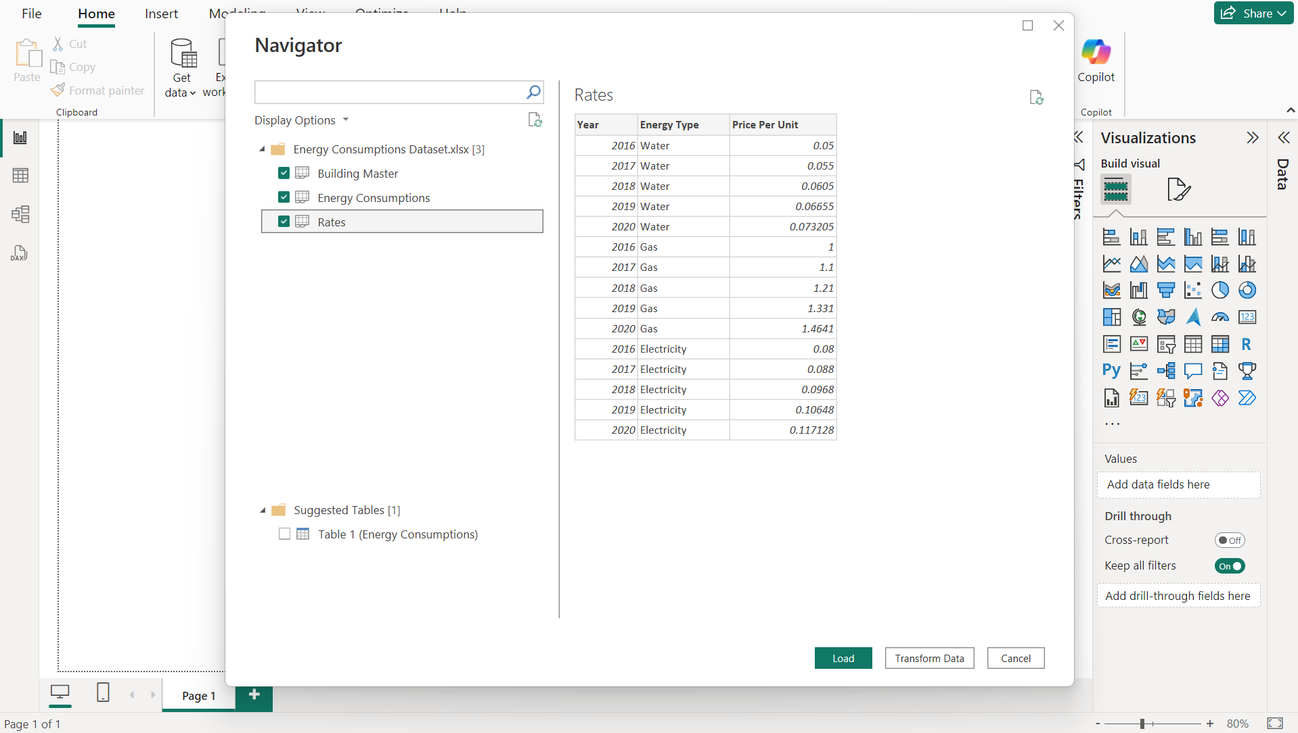

* Now before loading the data, we need to do some modifications to the original data for our analysis. So, choosing “Transform” option.
* Here for the table – **Building Master**, we can see that the column names are incorrect and we need to make our first row as our column names. So choosing option “**Use First Row as Headers**”.  
  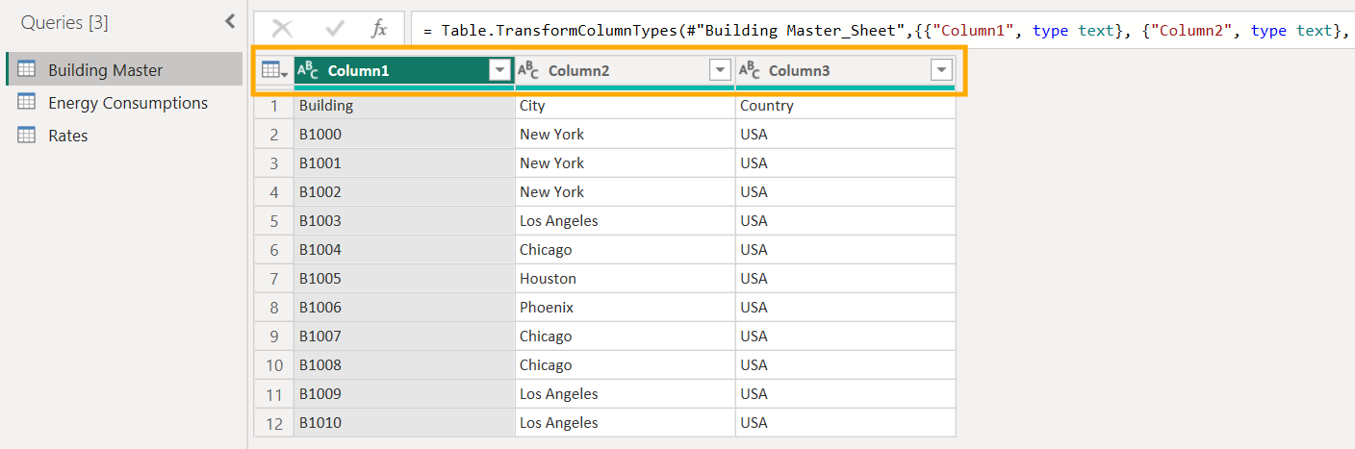

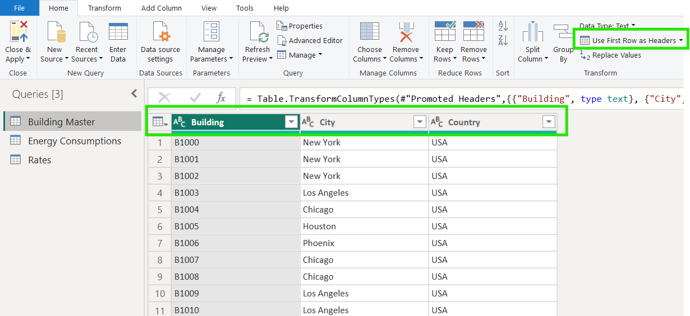

* Next, moving on to the other table – **Energy Consumptions**. Here we can see that columns – Water Consumption, Electricity Consumption, Gas Consumption are representing the attribute of energy consuming type by an individual building, so we can unpivot these 3 columns as attribute-value pairs for our analysis.

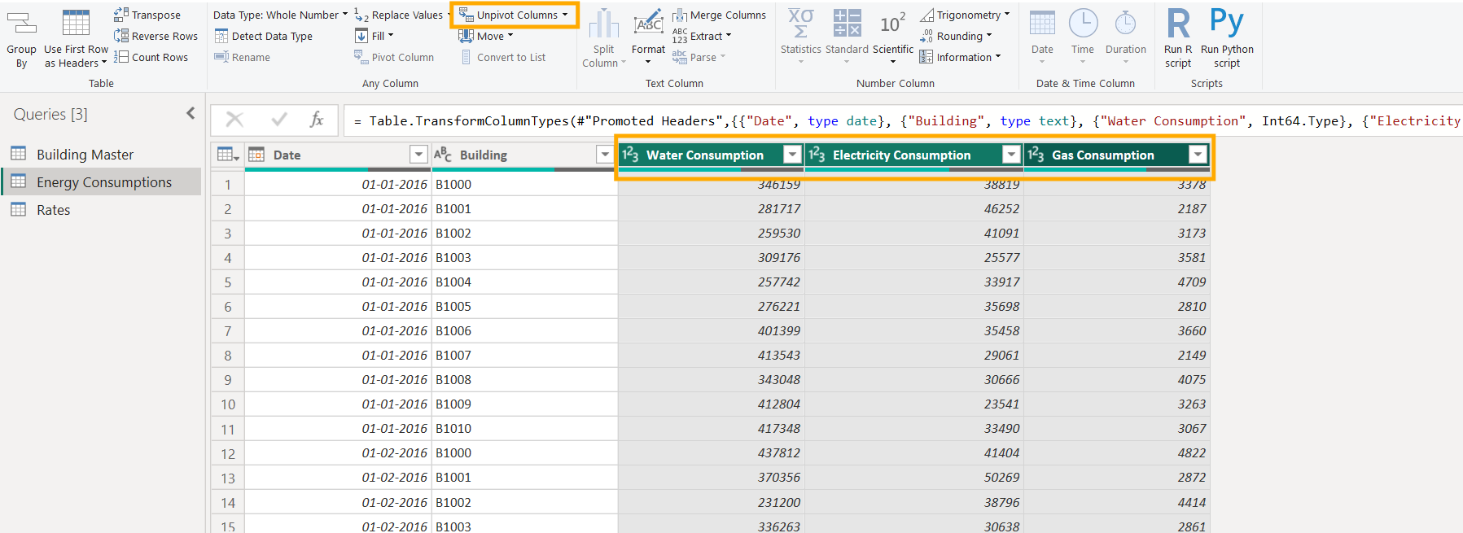

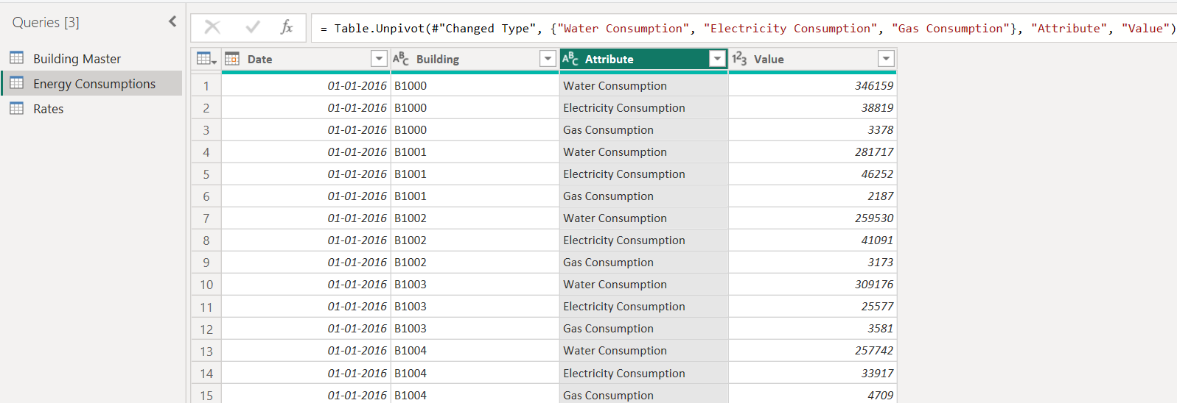

* After that transformation, changing the default column name – Attribute as “**Consumption Type**” for better readability. Also removing the word “consumption” from the row values, since its already we mentioned in column name by using “**Replace with**” option.

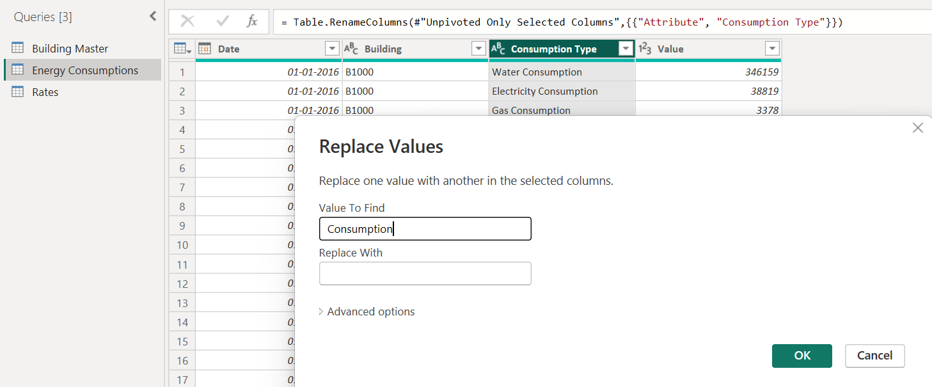

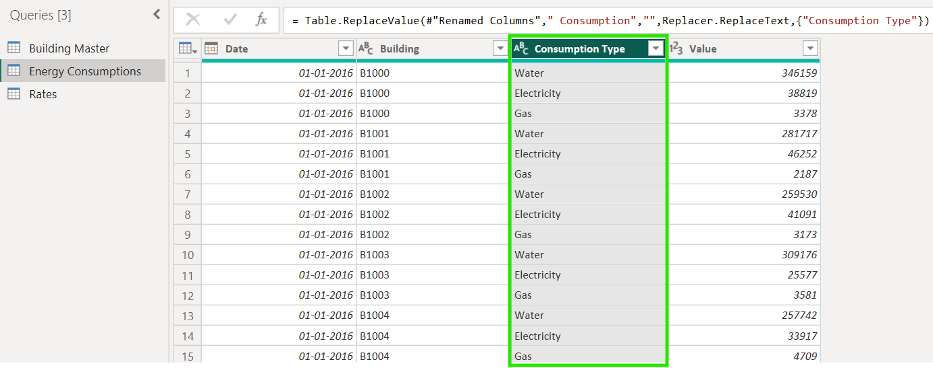

* **DATA MODELLING – Steps Done:**
* Next, we are going to create 2 new columns for establishing relationship between these tables. In table **Rates,** we created a new column “key” which contains merged values from year and energy type column.

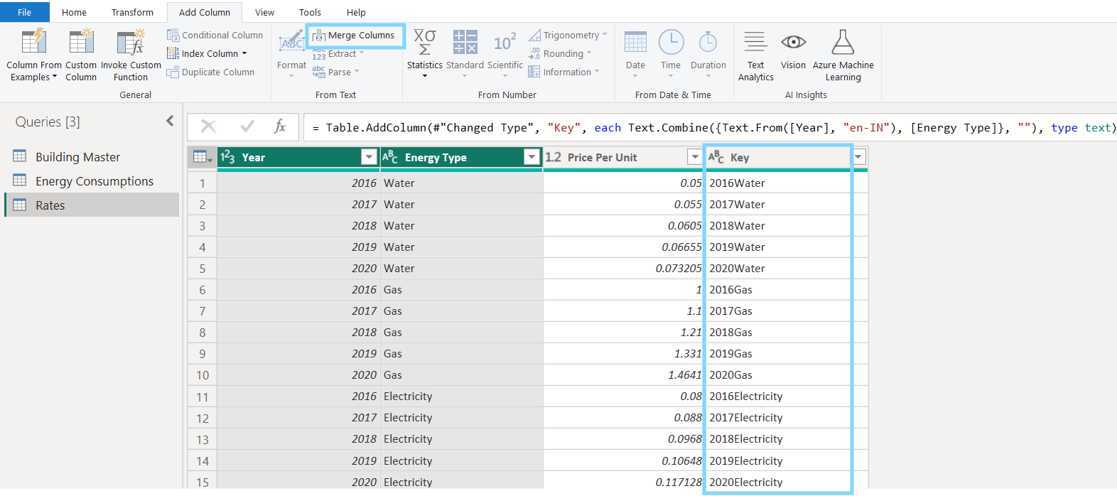

* Now going back to Energy Consumption table, we can see that there is no separate column for year. So first we need to extract year from the Date column and make a new column using it.
* Next, using that newly created year column, we create another new column using merged values of year and Consumption Type as below.

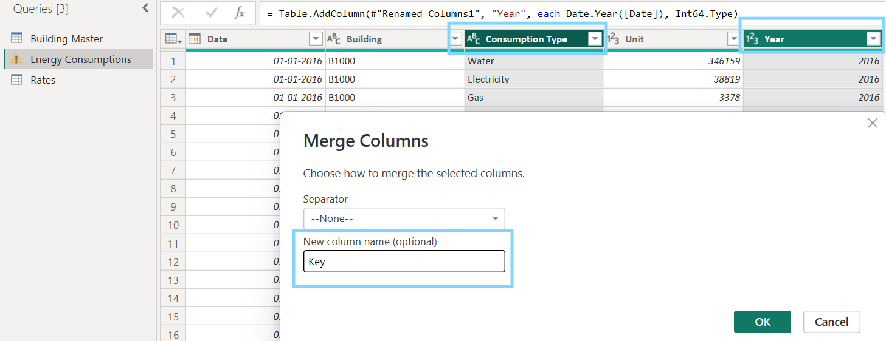

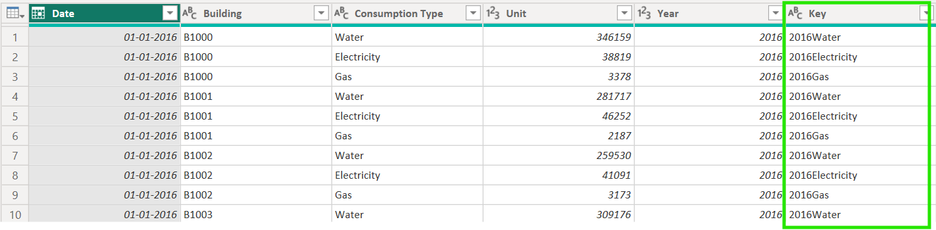

* All required transformations are done now, so then we can apply this and load the data for further analysis.

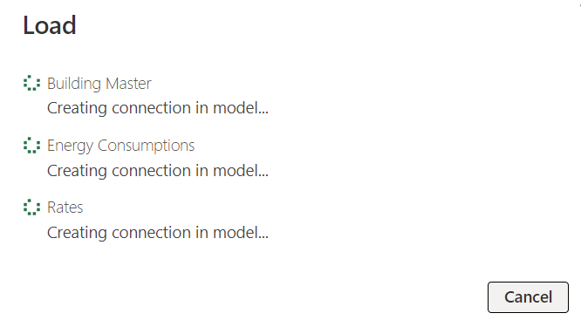

* Now we can verify whether all columns in the tables are loaded successfully under Data view.

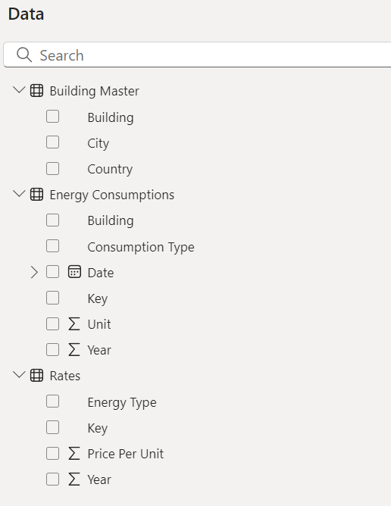

* We can also check the relationship between tables under Model view. We can see that between Building master and Energy Consumption table, there is a 1:many relationship with related column as “**Building**”.

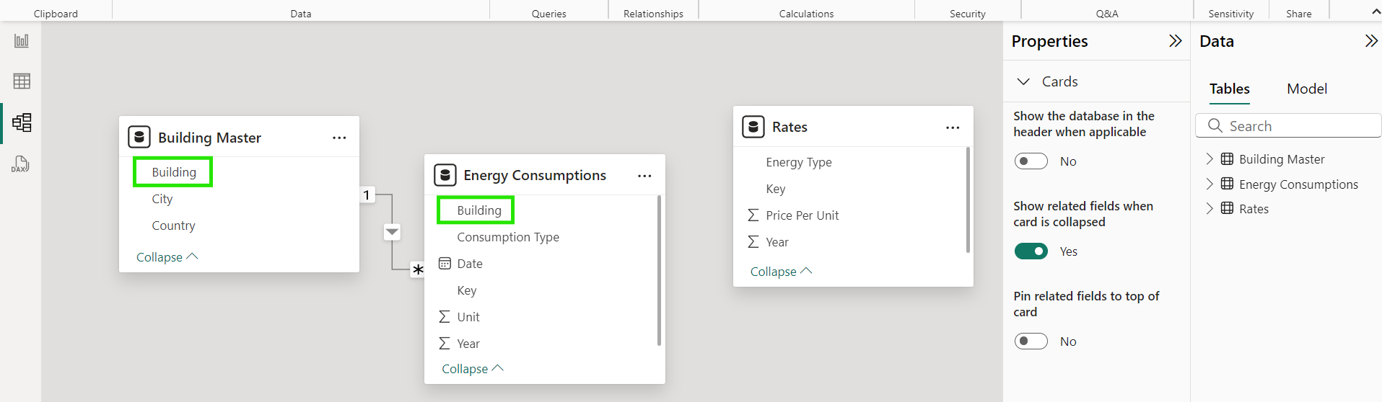

* We can also manually create new relationship like below. Eg, between rates and Energy Consumption tables with Key as related column.

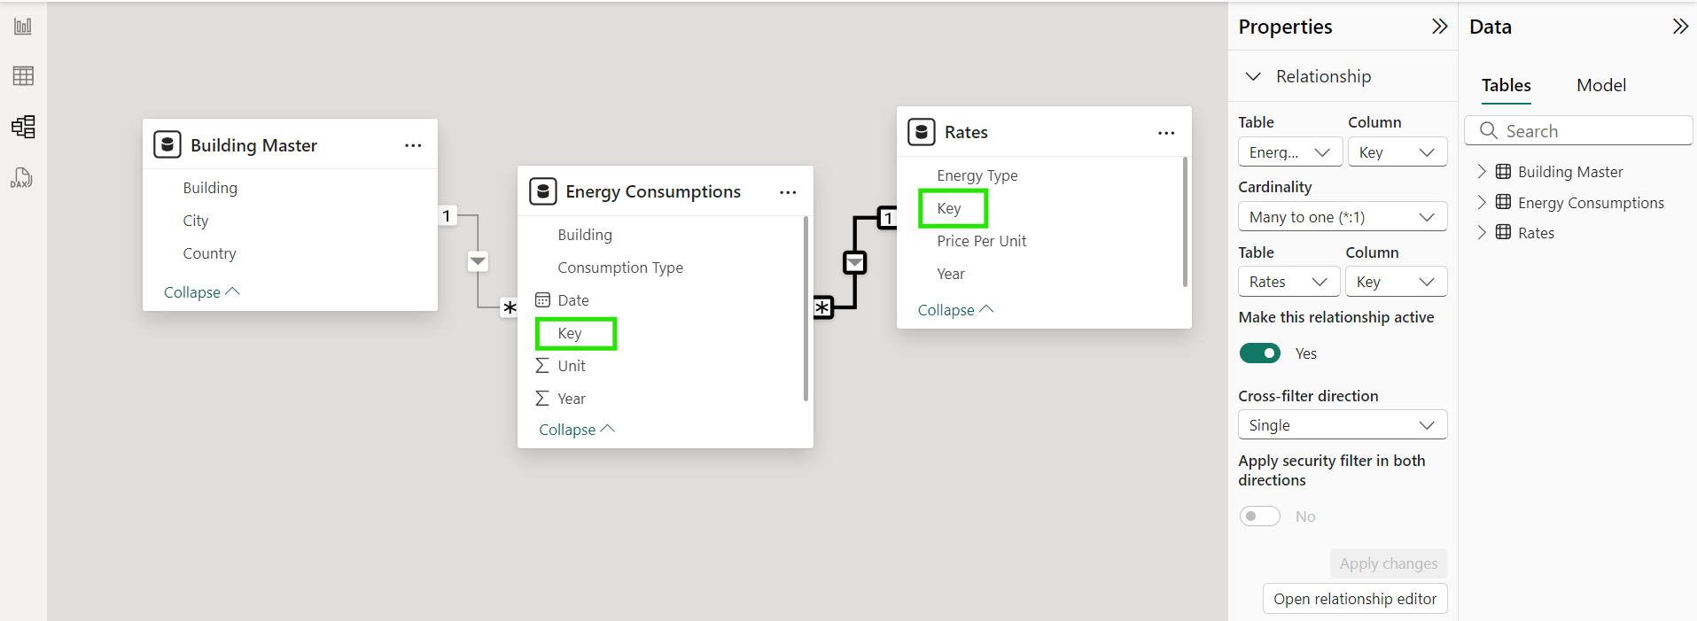

* **CONCLUSION:**

Below tasks are completed as part of Week-1 milestone.

* Understood the project aim.
* Identified the business requirements and tools needed.
* Learnt the basics of Power BI.
* Performed necessary data wrangling and loaded data into Power BI application.
* Created relationships between the loaded tables.
* Successfully imported the data into Power BI.